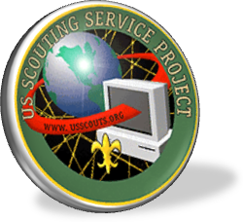
U.S. Scouting Service Project
A Scouting Portal Website created by Scouters for Scouters

Visit us at http://usscouts.org or any of our other 20 websites.

